STARCOM21
ITTF Interoperability
Radio SOP

Instructions for Use
This SOP Template provides a common framework for the development of a Standard Operating Procedure covering the STARCOM21 Interoperable Communication Platform that is used operated by agencies inof the State of Illinois.

It may also be used to develop SOPs for the use of local operability radio systems by making appropriate additions, deletions and substitutions that are relevant to use of the local systems.

The SOP template provides the agency with the content necessary for the efficient management and deployment of this resource. It has been designed to work in concert with the State of Illinois Tactical Interoperable Communications Plan (TICP) and local TICPs to help emergency responders coordinate their efforts more effectively.

Each agency has a substantial amount of latitude in the content of the completed SOP. However, there are specific procedures and verbiage in the template that should be included in each agency’s SOP. These very necessary statements and procedures are identified in the template with a normal font and should be included, without revision, in the completed SOP (unless NOT appropriate for local NON-STARCOM21 systems.

Examples and guidance in the form of suggested content and best practices are provided in an underlined font. Agencies may choose to use or ignore these procedures or statements and should delete any content that is NOT utilized prior to the completion of the SOP.

Any acronyms included in this document that are not already defined in the Glossary should be added to the Glossary.

Please feel free to expand or copy any of the tables provided in the various Appendices as you see fit for your organization.

If you have any questions about the use of this template, you may direct them to:

IEMA Interoperable Communications website: http://www.state.il.us/iema/SCIP.asp

Alan Choutka, Deputy Statewide Interoperability Coordinator
Ph: 874.450.9047 or alan.choutka@illinois.gov

Joe Galvin, Deputy Statewide Interoperability Coordinator
Ph: 312.833.1823 or joe.galvin@illinois.gov

Your agency name
[REPLACE WITH YOUR AGENCY LOGO AND RESIZE]

Standard Operating Procedure for
STARCOM21 Interoperability Radio

Information in this Standard Operating Procedure is designated as For Official Use Only (FOUO) and should be handled as sensitive information that is not to be disclosed. This document may be considered to be exempt from the provisions of the Illinois Freedom of Information Act under the exemptions detailed in 5 ILCS 140/7(1) (v). Reproduction of this document, in whole or in part, without prior approval from the [AGENCY NAME] is prohibited.

ADOPTION AND NIMS COMPLIANCE REVIEW

This Standard Operating Procedure is hereby adopted. Authorized signature(s) below confirm that this SOP document has been reviewed by the [AGENCY] for compliance with the National Incident Management System.

Signature |  | Printed Name |  | Title |  | Date

Signature |  | Printed Name |  | Title |  | Date

Signature |  | Printed Name |  | Title |  | Date

Signature |  | Printed Name |  | Title |  | Date

Record of Change

Change No. | Description | Change Date | Approved By
001

This Standard Operating Procedure (SOP) is subject to information and/or equipment updates and changes. The use of this Record of Change helps manage SOP modifications throughout the life of this document. All attempts have been made to ensure the accuracy of the information within this SOP as of the initial distribution date. Any subsequent adjustments should be logged and coordinated with user agencies within the State.

Table of Contents
I. Purpose 4
II. INTEROPERABLE COMMUNICATION RESOURCE DESCRIPTION 5
Overview 5
Functions and roles 5
General responsibilities 5
III. Rules of Use 7
Eligibility 7
Authorization 7
Radio Talkgroup and Channel Templates 8
IV. General communications Assets Rules of Use 10
NIMS/ICS/Plain Language/Unit Identification 10
Calling another unit 10
General Rules of Use of Communications Equipment 10
V. GLOSSARY AND TERMS 12
Appendix A AGENCY STARCOM21 POINTS OF CONTACT A-1
Appendix B INVENTORY & RADIO PROGAMMING DATA B-1
Appendix C RADIO QUICK START GUIDES C-1
Appendix D TEMPLATES AND MAPS D-1
Appendix E Radio Manuals E-1

Purpose
This Standard Operating Procedure (SOP) provides information on the procedure necessary for the efficient operation of the ITTF-provided STARCOM21 radios as well as any other STARCOM21 radio used for interoperability, specifically any radio that has been programmed with the Statewide Interoperability Template.

This SOP includes the following:
- Interoperable Communication Resource Description
- Rules of Use
- Glossary and Terms
- Points of Contact
- STARCOM21 Statewide Interoperability Templates and other tools
- Radio Manuals

INTEROPERABLE COMMUNICATION RESOURCE DESCRIPTION

Overview
- Illinois Terrorism Taskforce provided this agency with a radio(s) to access the STARCOM21 statewide platform to be used during incidents, events, or exercises
- This agency has the following radio(s) located as follows:
  - Radio 1: EXAMPLE Motorola XTL5000 Mobile radio mounted in the Chief’s Command Vehicle
  - Radio 2: Other (if applicable) Otherwise delete this text

Functions and roles
- The ITTF-supplied STARCOM21 radio is to be used for the following:
  - Command and Control – The radio may be used for department administration to receive important instructions from the State
    - During an incident (an emergency situation)
    - During an event (a planned situation)
  - Regional and/or Statewide Nets (tests)
  - Exercises in our area
- If your agency uses STARCOM21 for daily operability, you may need to add more functions and roles here – Otherwise delete this text

General responsibilities
            - Participate in Monthly and Semi-Annual Radio Nets (tests)
              - To verify system access to the STARCOM21 platform
              - Train staff on using radios
              - Understand the Statewide Interoperability Template
- Maintain the radio(s) in a state of readiness
  - Installed and properly working with antenna connected
  - In a continuously operating state or stored in safe but accessible location
  - Monitored 7 days a week, 24 hours a day (if possible)
  - Fully charged (portable radios)
  - The latest Statewide Interoperability Template is loaded
    - Check http://www.state.il.us/iema/SCIP.asp for any updates
  - Knowledge of how to change modes and zones in the radio
    - See Quick Start Guides – Appendix C

            - Return Policy
              - If for any reason a radio is no longer being used, it should be returned following the steps shown below:
                - Contact the organization that provided it (IESMA, ILEAS, MABAS)
-Or-
                - Contact the Statewide Interoperability Coordinator (SWIC). For reference the SWIC is the IEMA Communications Officer
                - Email the SWIC at ema.scip@illinois.gov
                - Or call IEMA Dispatch (800.782.7860) and ask for the IEMA Communications Officer

Rules of Use

Eligibility
STARCOM21 may be used for the following conditions:
- Command and Control
- Notification / important information from the State
- Monthly Nets (test)
- Exercises (quarterly, or approved in advance by the COMC)
- During an incident (emergency)
- During an event (planned)

As a general statement all agencies should listen to the “B” talkgroup for their IEMA Region.
Example: if your agency is in IEMA Region 7, you should listen to RGN 7B.
EXCEPTION:
If directed to by an appropriate statewide discipline-oriented organization follow
protocols established by that organizations (IESMA, ILEAS, MABAS, Public Health,
and/or IPWMAN) for the monitoring and use of their talkgroups.

The SIEC and ITTF Communications Committee recommend that all STARCOM21 radios have the Statewide Interoperability Template included.

Motorola Solutions has agreed to include the Statewide Interoperability Template when newly purchased radios are being programmed.

Both the “current” and “new” templates should be programmed into each radio unless the radio is limited in capacity, in which case a one or three zone Interoperability template is available.

Authorization
Additional Talkgroups Needed
The Regional A and B (example: RGN 4A or RGN 4B) talkgroups are named for the IEMA Regions and can be used (B first, then A if you need a second talkgroup) for any training, drill, exercise, event (planned) , or incident (emergency) without asking anyone’s permission provided that no one else is using the talkgroup(s).

The location (county/IEMA Region) where the radio(s) will be used will determine the correct B and A talkgroups.

If any additional talkgroups are needed, the event/incident COML must seek permission and talkgroup assignment from the State COMC or IEMA Communications Officer – 800.782.7860.

The role of the COMC is to coordinate the communications plans and critical resources needed at multiple simultaneous incidents and/or events either from an Area Command or the State Incident Response Center (SIRC).

Patches (Gateways) – Via console or other interconnect device
Establishing a patch on a permanent basis within STARCOM21 will need the approval of the STARCOM21 Advisory Subcommittee.

If a TEMPORARY patch during an event or incident is needed, that temporary interoperable link may only be done under the direction of a COML.

ISPERN Patch
Each ISP Communication Center has the ability to create console patches. One of the patches at each of the communication centers is dedicated to connecting VHF ISPERN with the ISP District’s STARCOM21 ISPERN talkgroup.

Monitoring
Monitoring interoperable talkgroup traffic of agencies in the vicinity is important and proper to provide situational awareness of what is happening in the area when using the Statewide Interoperability Template.

There are no fees to the user associated with any ITTF-supplied STARCOM21 radio as long as it is used for interoperability only.

Listening to a talkgroup that is active outside of the local area for the purpose of “just listening” is prohibited.

The “dragging” of communication traffic from one area of the state to another area takes precious channel resources out of action for others to use. Only listen to designated/authorized talkgroups.

Monthly Directed Radio Nets
Directed Nets are conducted in each of the eight IEMA regions at 10:30 am on the first Tuesday of each month. Set the radio to the “B” talkgroup for the correct IEMA Region.
Example: If in IEMA Region 4, set the radio to the “RGN 4B” talkgroup.

If the agency is called by Net Control then respond “<<Agency Name>> checking in;” if it is not called, then at the end of the net the Net Control station should ask if there are any additional stations that wish to check in. At this point check in with the net by identifying your agency with “<<Agency Name>> checking in.” From then on the agency should be called during the directed part of the Net each month.

Semi-Annual Open Radio Nets
The statewide open net will be conducted twice per year to give the users an opportunity to move through the interoperability template to a talkgroup that they would not regularly use. The talkgroup used will be announced at the regularly scheduled monthly net. Radio net participants will change to the alternate talkgroup and announce their presence. The statewide open net will not call role, instead users take turns and check in when there is an appropriate time to do so. Users can simply say “<<Agency Name>> checking in;”

Radio Talkgroup and Channel Templates
The Statewide Interoperability Template was developed to provide an organized, uniform and consistent set of interoperable STARCOM21 talkgroups along with the National Interoperable Pool (NIP) 700 and 800 MHZ interoperable channels.

The 3 versions are: (CURRRENT and NEW templates in Appendix D)
    - ORIGINAL – this version was installed when the radios were first distributed. It included a talk group for each of the 19 Homeland Security Regions. This template is NOT to be used.
    - CURRENT (AA-AG) – this version includes the STARCOM21 interoperability talkgroups as well as the 700 and 800 MHz National Interoperable Pool (NIP) channels that were current in 2006.
    - NEW (BA-BI) – this version includes the expanded list of STARCOM21 interoperability talkgroups and the latest designated 700 and 800 MHz NIP channels per the 2010 ANSI Standard. This template is to be loaded into all newly purchased radios along with the CURRENT template.

The templates can be downloaded from http://www.state.il.us/iema/SCIP.asp.

A copy of the template should be kept by the radio to assist in navigating to other talkgroups and/or channels.

The first section of the Statewide Interoperability Template talkgroup list is discipline-specific, primarily for statewide hailing, dispatch or convoy use. These talkgroups are
- IESMA - Illinois Emergency Services Management Association,
- ILEAS - Illinois Law Enforcement Alarm System,
- MABAS - Mutual Aid Box Alarm System,
- PUB HLTH - Illinois Public Health,
- IPWMAN - Illinois Public Works Mutual Aid Network. (Only in the NEW Template)

The second section consists of the statewide Incident talkgroups 1 through 5 (INCDNT 4 & 5 are only in the NEW Template).

The third section is based on subdividing the State into three geographic areas. These talkgroups are named Zone 1, 2, 3 in the CURRENT template and in the NEW template as North, Center and South with 2 talkgroups (A&B) for each of the three areas.

The last section is made up of two talkgroups (A & B) for each of the IEMA Regions (2, 3, 4, 6, 7, 8, 9, & 11).

Some talkgroups are designated for statewide use. Others are for use within a geographic area of the state while others are for use within a particular IEMA Region. The “discipline” talkgroups (IESMA, ILEAS, MABAS, PUB HLTH and IPWMAN along with the “incident” (INCDNT 1, 2, 3, 4, 5) talkgroups are for statewide use.

The IESMA talkgroup is the only talkgroup monitored continuously. It is used as the statewide hailing channel and monitored by the IEMA Communication Center in Springfield 24 hours/day, 7 days/week.

Special Note about Tone Remote Control
STARCOM21 consolette radios that are integrated into radio dispatch consoles and are accessed by Tone Control may be programmed with a special template because of limitations in the implementation of tone control.

General communications Assets Rules of Use

NIMS/ICS/Plain Language/Unit Identification

National Incident Management System – Use of an Incident Command System compliant with the National Incident Management System is recommended for use of any regional interoperability resource, i.e. having a Communications Unit Leader involved in the event issuing a communications plan.

It is the responsibility of the Incident Commander/designee to establish the tactical call signs to be used for incident facilities and/or staff if NOT an ICS common facility/staff term and NOT specified in agency SOPs. It is the responsibility of all users to refer to facilities and staff by the proper tactical call signs.

Plain language – All Communications should be in plain language. Radio codes, acronyms and abbreviations are to be avoided as they may cause confusion between agencies. The reason for a request for assistance or backup should be clearly stated.

Unit Identification–Agency name followed by identifier or resource type (i.e., ILEAS 5, Madison County 84, etc.).

Calling another unit
Users should call other users using the “called unit from calling unit” format (also known as the “hey you –it’s me” format) using unit identifiers,
as in: “Madison County 84 from ILEAS 5”
Followed by: “ILEAS 5 from Madison County 84, go ahead”

General Rules of Use of Communications Equipment
- Communications equipment shall only be used for official business or emergency communications.

- Any use of any interoperable channel or equipment shall be consistent with Federal Communications Commission (FCC) Rules

- Use of interoperable channels during a level 3, 2, or 1 incident will be authorized by the COML of the incident.

- Users will make every effort to verify that the interoperability channel is clear before beginning transmission to avoid covering up or interrupting the communications of a current user.

- Rules and Guidelines of existing interoperable channels or talkgroups (i.e., ISPERN, IREACH, STARCOM21, etc.) will be followed when using those channels or talkgroups.

- All voice radio communications are to be brief and concise.

- No obscene, indecent or profane language shall be used on any channel.

- No use of first names, slang or CB type handles shall be used on any interoperable channels. (Investigative units in compromising positions or Tactical Response Units in full operations and only as absolutely necessary may be exceptions to this rule with approval of the COML in level 3 or above interoperability).

- All users are reminded that interoperable channels patched to the STARCOM21 platform cover a wide area and may be heard for many miles by many users.

- Units overhearing unauthorized use are encouraged to bring the unauthorized use to the attention of the violator immediately and if the aberrant behavior persists bring the concern to the attention of the local COML, Incident Commander, SWIC, STARCOM21 Oversight Committee or SIEC at the earliest opportunity.

- When a communication asset is made available, additional procedures related to the specific asset may apply. The user will refer to the relevant section of local or state TICP for those additional procedures. If an asset is not listed in the plan, permission to use the asset must be sought by the appropriate authority prior to placing the asset in service.

- Encryption shall not be used at any time on any simplex, State or National interoperable channel, including ISPERN, IREACH, IFERN, MERCI. During level 3 and above operations, encryption shall NOT be used in the theatre of operation without the authorization of the COMC/COML.

- Ground to Air Communications - During a level 3, 2, or 1 incident, ground to air and air to ground operations shall be coordinated with the COMC/COML. Airborne use of interoperable channels shall receive prior authorization from COMC/COML. (Any use of interoperable channels by airborne units must be mindful of the longer range of communications while airborne).

GLOSSARY AND TERMS
Item/Acronym | Definition
COMC | Communications Coordinator
COML | Communications Unit Leader
Event (Planned) | Any situation that is not an incident. An event (non-emergency) maybe but is not limited to:  - Training evolutions and training exercise, or  - Routine maintenance of vehicle, equipment or accessories, or  - Public education demonstration, or  - Parade Community celebration, etc.
ICS | Incident Command System
Incident (Emergency) | Any situation that poses an immediate risk to health, life, property or environment. An incident (Emergency) typically occurs with little or no warning and requires urgent intervention to prevent a worsening of the situation.
Interoperable Communication Resource | Any item of equipment, system or subsystem that is used to provide or enhance interoperable communications within or between one or more agencies.
ITTF | Illinois Terrorism Task Force
MOA | Memorandum of Agreement
MOU | Memorandum of Understanding
Mutual Aid | Personnel, equipment, or services provided to another jurisdiction
NIMS | National Incident Management System
POC | Point of Contact
SCIP | Statewide Communications Interoperability Plan
SEOC | State Emergency Operation Center
SIRC | State Incident Response Center – Room located inside the SEOC
SOP | Standard Operating Procedure
SWIC | Statewide Interoperability Coordinator
TICP | Tactical Interoperable Communications Plan

AGENCY STARCOM21 POINTS OF CONTACT
Table 1 - Points of Contact
POC Type | Name | Agency or  Organization | Email | Phone  24 Hr Phone
Dispatch Center | Name | Agency | Email | Bus phone  24 hr phone
Resource Agency (Main) | Name | Agency | Email | Bus phone  24 hr phone
Resource Agency (Alternate) | Name | Agency | Email | Bus phone  24 hr phone

INVENTORY & RADIO PROGAMMING DATA
Provide detailed information of Interoperable Communication Resource equipment, including make, model, quantity, etc. For radio equipment include a copy of the Radio Data Table for each type of radio. See examples below. USE THOSE THAT APPLY AND DELETE THE REST. Delete this text when finished

Table 1- Inventory

Inventory
Radio | Radio Location | Radio Type | Model Number | Serial Number
1
2
3
4
5
6
7
8
9

Data shown in Column “xx” on the following Radio Data Tables is for EXAMPLE ONLY and should be replaced with data for the radio(s) that the agency has. Delete this text when finished

Table 2 - Radio Data Table (Duplicate/Delete as necessary)
Radio Specifications Programming Template
Qty | xx
Radio Mobile/Portable | Mobile |  | Daily Operability Zones
Mfg | Motorola | Ch/Mode | A | B | C | D | E | F | G
Model | XTL5000 | 1
Band | 700/800 | 2
Trunked/Conv | Both | 3
Trunked System | Yes | 4
Charger Included | N/A | 5
Holster Included | N/A | 6
Speaker Mic Incl. | N | 7
Programming cable avail | Y | 8
Programming cable avail | Y | 9
Programming software avail | Y | 10
Programming software avail | Y | 11
 |  | 12
 |  | 13
 |  | 14
 |  | 15
 |  | 16

Table 3 - Radio Data Table (Duplicate/Delete as necessary)

Radio Specifications Programming Template (CURRENT AA - AG)
Qty | xx
Radio Mobile/Portable | Mobile |  | Statewide Interoperability Zone
Mfg | Motorola | Ch/Mode | AA | AB | AC | AD | AE | AF | AG
Model | XTL5000 | 1 | IESMA | RGN 6A | 7 TAC 58D | 7 TAC 74D | 7 CAL 59D | I-CALL D | 8CAL-90D
Band | 700/800 | 2 | ILEAS | RGN 6B | 7 TAC 62D | 7 TAC 78D | 7 TAC 63D | I-TAC 1 D | 8TAC-91D
Trunked/Conv | Both | 3 | MABAS | RGN 7A | 7 TAC 66D | 7 TAC 82D | 7 TAC 67D | I-TAC 2 D | 8TAC-92D
Trunked System | Yes | 4 | PUB HLTH | RGN 7B | 7 LAW 68D | 7 LAW 84D | 7 TAC 73D | I-TAC 3 D | 8TAC-93D
Charger Included | N/A | 5 | INCDNT 1 | RGN 8A | 7 LAW 69D | 7 LAW 85D | 7 CAL 75D | I-TAC 4 D | 8TAC-94D
Holster Included | N/A | 6 | INCDNT 2 | RGN 8B | 7 TAC 70D | 7 TAC 86D | 7 TAC 79D | I-CALL R | 8CAL-90R
Speaker Mic Incl. | N | 7 | INCDNT 3 | RGN 9A | 7 MOB 72D | 7 MOB 88D | 7 TAC 83D | I-TAC 1 R | 8TAC-91R
Programming cable avail | Y | 8 | ZONE 1 | RGN 9B | 7 TAC 58 | 7 TAC 74 | 7 TAC 89D | I-TAC 2 R | 8TAC-92R
Programming cable avail | Y | 9 | ZONE 2 | RGN 11A | 7 TAC 62 | 7 TAC 78 | 7 CAL 59 | I-TAC 3 R | 8TAC-93R
Programming software avail | Y | 10 | ZONE 3 | RGN 11B | 7 TAC 66 | 7 TAC 82 | 7 TAC 63 | I-TAC 4 R | 8TAC-94R
Programming software avail | Y | 11 | RGN 2A |  | 7 LAW 68 | 7 LAW 84 | 7 TAC 67
 |  | 12 | RGN 2B |  | 7 LAW 69 | 7 LAW 85 | 7 TAC 73
 |  | 13 | RGN 3A |  | 7 TAC 70 | 7 TAC 86 | 7 CAL 75
 |  | 14 | RGN 3B |  | 7 MOB 72 | 7 MOB 88 | 7 TAC 79
 |  | 15 | RGN 4A |  |  |  | 7 TAC 83
 |  | 16 | RGN 4B |  |  |  | 7 TAC 89

Table 4 - Radio Data Table (Duplicate/Delete as necessary)
Radio Specifications Programming Template (NEW BA-BI)
Qty | xx
Radio Mobile/Portable | Mobile |  | Statewide Interoperability Zone
Mfg | Motorola | Ch/Mode | BA | BB | BC | BD | BE | BF | BG | BH | BI
Model | XTL5000 | 1 | IESMA | RGN 2A | 8CALL90D | 7CALL50D | 7MOB59D | 7CALL70D | 7MOB79D | 7FTAC1D | 7MTAC9D
Band | 700/800 | 2 | ILEAS | RGN 2B | 8TAC91D | 7TAC51D | 7MOB59DA | 7TAC71D | 7MOB79DA | 7FTAC2D | 7NTAC10D
Trunked/Conv | Both | 3 | MABAS | RGN 3A | 8TAC92D | 7TAC52D | 7LAW61D | 7TAC72D | 7LAW81D | 7FTAC3D | 7NTAC11D
Trunked System | Yes | 4 | PUB HLTH | RGN 3B | 8TAC93D | 7TAC53D | 7LAW62D | 7TAC73D | 7LAW82D | 7GTAC4D | 7NTAC12D
Charger Included | N/A | 5 | IPWMAN | RGN 4A | 8TAC94D | 7TAC54D | 7FIRE63D | 7TAC74D | 7FIRE83D | 7GTAC5D | 7MTAC9
Holster Included | N/A | 6 | INCDNT 1 | RGN 4B | 8CALL90 | 7TAC55D | 7FIRE64D | 7TAC75D | 7FIRE84D | 7LTAC6D | 7NTAC10
Speaker Mic Incl. | N | 7 | INCDNT 2 | RGN 6A | 8TAC91 | 7TAC56D | 7MED65D | 7TAC76D | 7MED86D | 7LTAC7D | 7NTAC11
Programming cable avail | Y | 8 | INCDNT 3 | RGN 6B | 8TAC92 | 7GTAC57D | 7MED66D | 7GTAC77D | 7MED87D | 7LTAC8D | 7NTAC12
Programming cable avail | Y | 9 | INCDNT 4 | RGN 7A | 8TAC93 | 7CALL50 | 7MOB59 | 7CALL70 | 7MOB79 | 7FTAC1
Programming software avail | Y | 10 | INCDNT 5 | RGN 7B | 8TAC94 | 7TAC51 | 7MOB59A | 7TAC71 | 7MOB79A | 7FTAC2
Programming software avail | Y | 11 | NORTH A | RGN 8A |  | 7TAC52 | 7LAW61 | 7TAC72 | 7LAW81 | 7FTAC3
 |  | 12 | NORTH B | RGN 8B |  | 7TAC53 | 7LAW62 | 7TAC73 | 7LAW82 | 7GTAC4
 |  | 13 | CENTER A | RGN 9A |  | 7TAC54 | 7FIRE63 | 7TAC74 | 7FIRE83 | 7GTAC5
 |  | 14 | CENTER B | RGN 9B |  | 7TAC55 | 7FIRE64 | 7TAC75 | 7FIRE84 | 7LTAC6
 |  | 15 | SOUTH A | RGN 11A |  | 7TAC56 | 7MED65 | 7TAC76 | 7MED86 | 7LTAC7
 |  | 16 | SOUTH B | RGN 11B |  | 7GTAC57 | 7MED66 | 7GTAC77 | 7MED87 | 7LTAC8

Table 5 - Radio Data Table (Duplicate/Delete as necessary)
Radio Specifications Programming Template (OLD CAMPUS RADIO)
Qty | xx
Radio Mobile/Portable | Mobile |  | Statewide Interoperability Zone
Mfg | Motorola | Ch/Mode | AA | AB | AC
Model | XTL5000 | 1 | IESMA | RGN 6A
Band | 700/800 | 2 | ILEAS | RGN 6B
Trunked/Conv | Both | 3 | MABAS | RGN 7A
Trunked System | Yes | 4 | PUB HLTH | RGN 7B
Charger Included | N/A | 5 | INCDNT 1 | RGN 8A
Holster Included | N/A | 6 | INCDNT 2 | RGN 8B
Speaker Mic Incl. | N | 7 | INCDNT 3 | RGN 9A
Programming cable avail | Y | 8 | ZONE 1 | RGN 9B
Programming cable avail | Y | 9 | ZONE 2 | RGN 11A
Programming software avail | Y | 10 | ZONE 3 | RGN 11B
Programming software avail | Y | 11 | RGN 2A
 |  | 12 | RGN 2B
 |  | 13 | RGN 3A
 |  | 14 | RGN 3B
 |  | 15 | RGN 4A
 |  | 16 | RGN 4B

Table 6 - Radio Data Table (Duplicate/Delete as necessary)
Radio Specifications Programming Template (NEW CAMPUS RADIO)
Qty | xx
Radio Mobile/Portable | Mobile |  | Statewide Interoperability Zone
Mfg | Motorola | Ch/Mode | BA | BB | BC
Model | XTL5000 | 1 | IESMA | RGN 2A | 8CALL90D
Band | 700/800 | 2 | ILEAS | RGN 2B | 8TAC91D
Trunked/Conv | Both | 3 | MABAS | RGN 3A | 8TAC92D
Trunked System | Yes | 4 | PUB HLTH | RGN 3B | 8TAC93D
Charger Included | N/A | 5 | IPWMAN | RGN 4A | 8TAC94D
Holster Included | N/A | 6 | INCDNT 1 | RGN 4B | 8CALL90
Speaker Mic Incl. | N | 7 | INCDNT 2 | RGN 6A | 8TAC91
Programming cable avail | Y | 8 | INCDNT 3 | RGN 6B | 8TAC92
Programming cable avail | Y | 9 | INCDNT 4 | RGN 7A | 8TAC93
Programming software avail | Y | 10 | INCDNT 5 | RGN 7B | 8TAC94
Programming software avail | Y | 11 | NORTH A | RGN 8A
 |  | 12 | NORTH B | RGN 8B
 |  | 13 | CENTER A | RGN 9A
 |  | 14 | CENTER B | RGN 9B
 |  | 15 | SOUTH A | RGN 11A
 |  | 16 | SOUTH B | RGN 11B
Table 7 - Radio Data Table (Duplicate/Delete as necessary)
Radio Specifications Programming Template (3 ZONE)
Qty | xx
Radio Mobile/Portable | Mobile |  | Statewide Interoperability Zone
Mfg | Motorola | Ch/Mode | BA | BB | BC
Model | XTL5000 | 1 | IESMA | RGN 2A | 8CALL90D
Band | 700/800 | 2 | ILEAS | RGN 2B | 8TAC91D
Trunked/Conv | Both | 3 | MABAS | RGN 3A | 8TAC92D
Trunked System | Yes | 4 | PUB HLTH | RGN 3B | 8TAC93D
Charger Included | N/A | 5 | IPWMAN | RGN 4A | 8TAC94D
Holster Included | N/A | 6 | INCDNT 1 | RGN 4B | 8CALL90
Speaker Mic Incl. | N | 7 | INCDNT 2 | RGN 6A | 8TAC91
Programming cable avail | Y | 8 | INCDNT 3 | RGN 6B | 8TAC92
Programming cable avail | Y | 9 | INCDNT 4 | RGN 7A | 8TAC93
Programming software avail | Y | 10 | INCDNT 5 | RGN 7B | 8TAC94
Programming software avail | Y | 11 | NORTH A | RGN 8A
 |  | 12 | NORTH B | RGN 8B
 |  | 13 | CENTER A | RGN 9A
 |  | 14 | CENTER B | RGN 9B
 |  | 15 | SOUTH A | RGN 11A
 |  | 16 | SOUTH B | RGN 11B

Table 8 - Radio Data Table (Duplicate/Delete as necessary)
Radio Specifications Programming Template (SINGLE ZONE)
Qty | xx
Radio Mobile/Portable | Mobile |  | Statewide Interoperability Zone
Mfg | Motorola | Ch/Mode | BA
Model | XTL5000 | 1 | IESMA
Band | 700/800 | 2 | ILEAS
Trunked/Conv | Both | 3 | MABAS
Trunked System | Yes | 4 | PUB HLTH
Charger Included | N/A | 5 | IPWMAN
Holster Included | N/A | 6 | INCDNT 1
Speaker Mic Incl. | N | 7 | (NORTH/CENTER/SOUTH) A
Programming cable avail | Y | 8 | (NORTH/CENTER/SOUTH) B
Programming cable avail | Y | 9 | RGN XA (Choose Region)
Programming software avail | Y | 10 | RGN XB (Choose Region)
Programming software avail | Y | 11 | 8CALL90D
 |  | 12 | 8TAC91D
 |  | 13 | 8TAC92D
 |  | 14 | 8CALL90
 |  | 15 | 8TAC91
 |  | 16 | 8TAC92

For Channels/Modes 7 and 8 in the table above select the appropriate geographic region of the state. Delete this text when finished.

RADIO QUICK START GUIDES

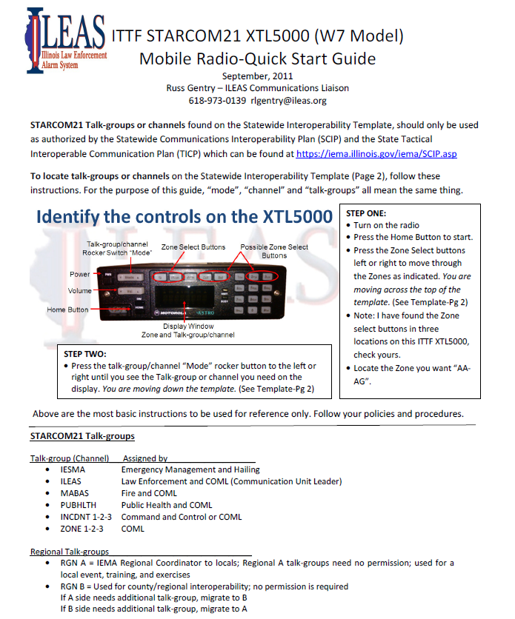

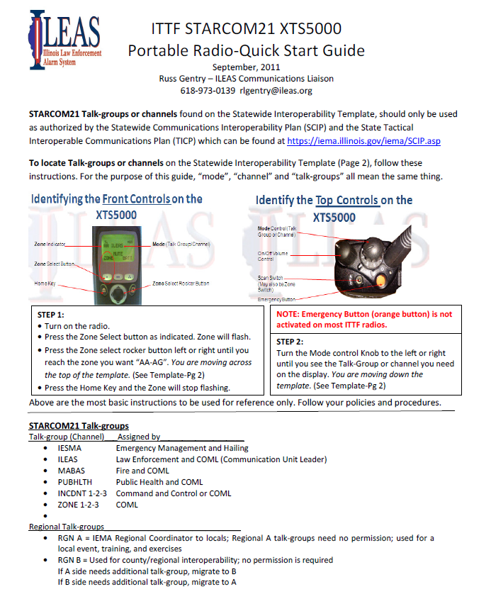

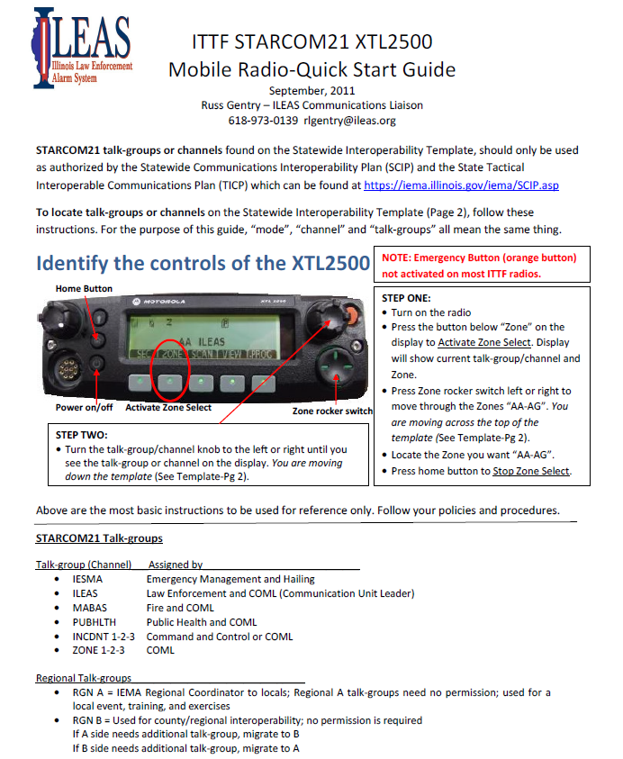

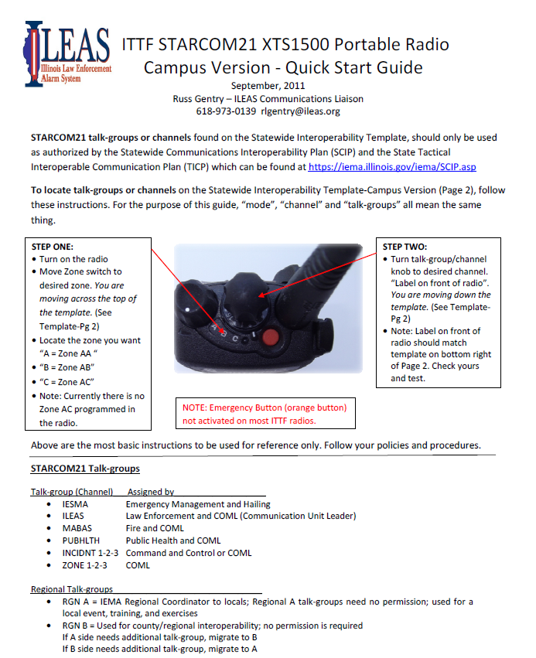

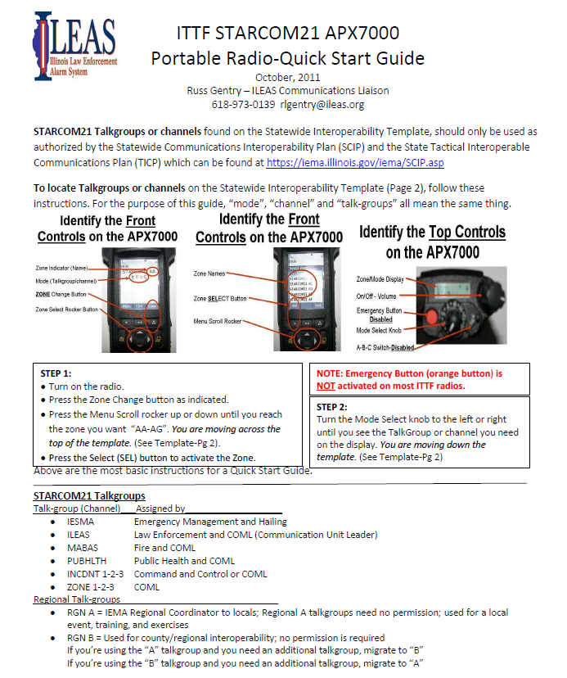

TEMPLATES AND MAPS
Statewide Interoperability Templates (Subject to change at any time)

CURRENT Statewide Interoperability Template
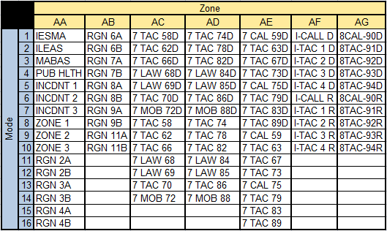

NEW Statewide Interoperability Template
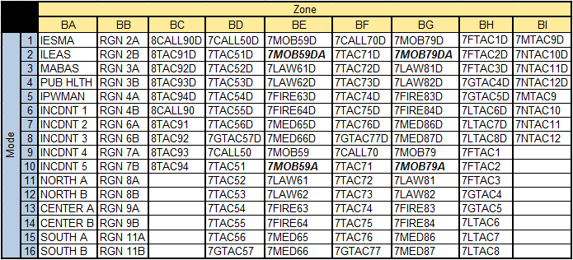

Statewide Interoperability Templates (Subject to change at any time)

NEW 3 Zone Interoperability Template NEW 1 Zone Interoperability Template
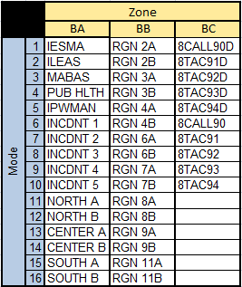
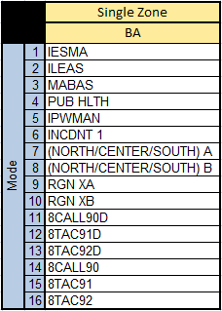

NOTE: For the single zone Interop Template; change Modes 7 & 8 to be affiliated with your geographic area and Modes 9 &10 to be affiliated with your IEMA Region.

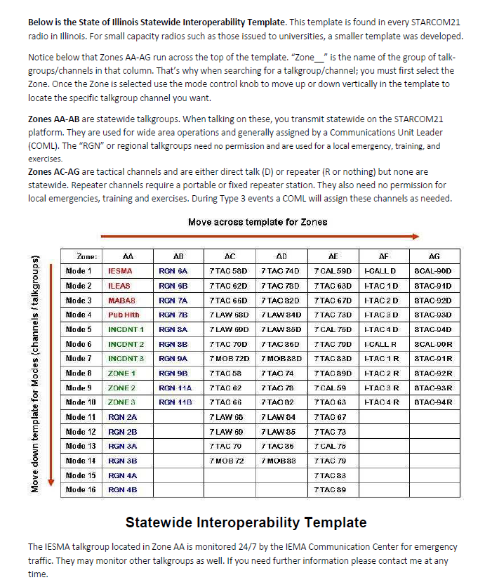
What IEMA Region is my agency located in?
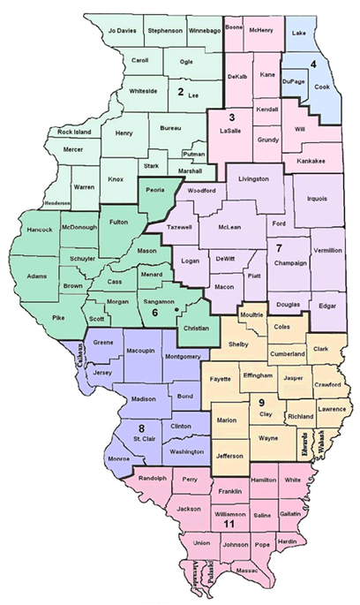

STARCOM21 geographic area (North, Center, or South) is my agency located in?
NEW Template:
North A
North B

Center A
Center B

South A
South B
CURRENT Template
Zone 1

Zone 2

Zone 3
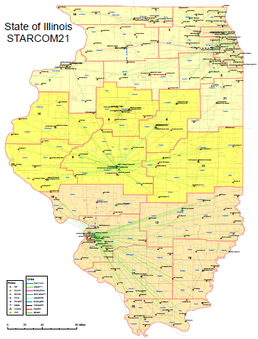

Radio Manuals
Include radio manuals here

